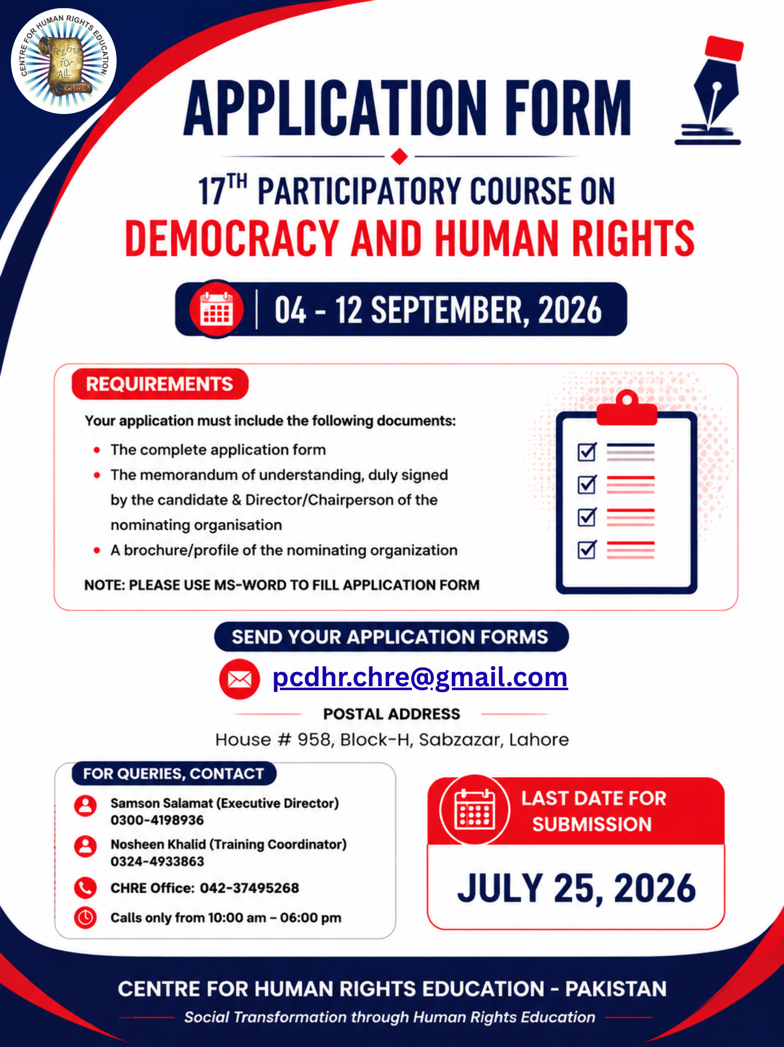
For internal use
Application No____________

APPLICATION FORM 17th PCDHR 2026 - 2027
Please complete all sections of application form. Incomplete application will not be processed.
Section B: Candidate Profile
Section A
For Official Use

How did you
learn
about
this training?

Form No______________

Date: ____________

Status: __________

Advertisement

from friend

Facebook

Website

E - -
Mail

Others
/ Reference
)
please specify
(

Name: |  |  |  |  |  |  |  | 
Sex/gender: |  |  | Date of Birth:
CNIC #: |  |  | Contact:
Email:
Academic  Qualification: |  |  |  |  |  |  |  | Insert Photo
Postal Address:
District & Province: |  |  |  | Working Status
Professional Experience (period):
Have you applied for any training of CHRE before |  |  |  | Yes No
If yes please mention

Please list Training's programs on Human Rights and Democracy you have previously attended:
Program Name, date and location |  |  |  |  |  | Host Organization

Section C: Organizational Profile
(not compulsory for students and for those applying in individual capacity)

Organization/Institution Name:

Job Designation:

Website: |  |  |  |  |  | Email:
Contact no: |  |  |  |  |  | Social media platforms:
Postal Address:
District & Province: |  |  |  |  |  | Year of Establishment
Working Area/ Places:
Three Major Activities:

Programs on Human Rights & Democracy:

Role of Candidate in these Activities/Programs

Type of Organization You Work for:
Community Based Organization (CBO) Local level NGO

National NGO International NGO

State / educational Institution Other, please specify

Section D: Understanding Regarding Human Rights and Democracy
Please define Human Rights in your own words (Maximum 300 words):
Please define Democracy in your own words (Maximum 300 words):
Situation analysis on human rights and democracy in Pakistan in your own perspective (Maximum 500 words):
Section E: Transfer of Learning

Please give the example (s) how the learning gained from the PCDHR will be put into practice in the work of your organization or in your personal capacity. (maximum 300 words)

Signature of Candidate Date

