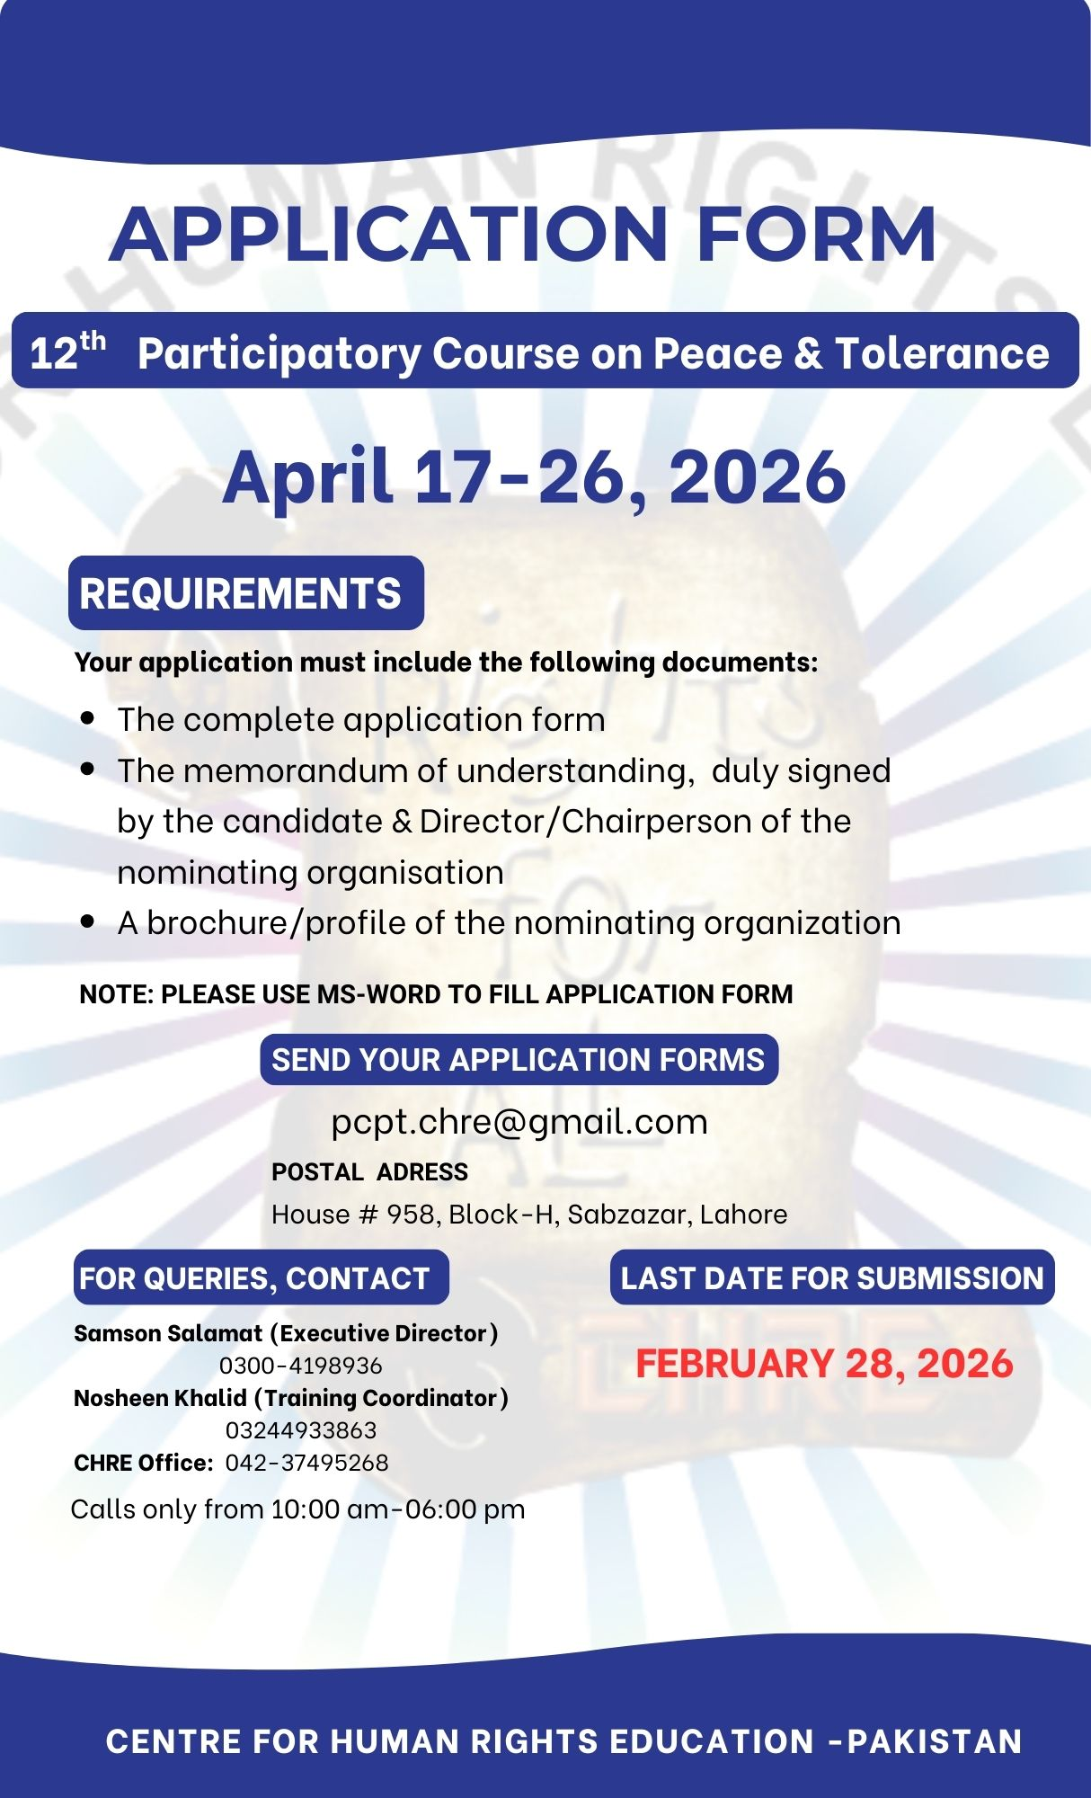

APPLICATION FORM 12th PCPT 2025
Please complete all sections of application form. Incomplete application will not be processed.
Section A:

For Official Use

How did you
learn
about
this training?

Form No______________

Date: ____________

Status: __________

Advertisement

from friend

Facebook

Website

E
-
Mail

Others
/ Reference
)
please specify
(

Section B: Candidate Profile
Name: |  |  |  |  |  |  |  |  | 
Gender: |  |  | Date of Birth:
CNIC #: |  |  | Contact:
Email:
Academic  Qualification: |  |  |  |  |  |  |  |  | Insert Photo
Postal Address:
Province: |  |  |  |  |  | Working Status
Professional Experience (period):
Please list Training Programs on Peace and Human Rights you have previously attended:
Program Name, date and location |  |  |  |  |  |  | Host Organization

Have you applied for any training of CHRE before |  |  |  |  |  |  |  | Yes No
If yes please mention

Section C: Organizational Profile
(not compulsory for students and for those applying in individual capacity)

Organization Name:

Job Designation:

Website: |  |  |  |  |  |  |  | Email:
Contact no: |  |  |  |  |  |  |  | Fax:
Postal Address:

Province: |  |  |  |  |  |  |  | Year of Establishment
Working Area/ Place:

Three Major Activities

Programs on Peace & Human Rights:

Role of Candidate in these Activities/Programs

Type of Organization You Work for:

Community Based Organization (CBO) Local level NGO

National NGO International NGO

State Institution Other, please specify

Section D: Understanding Regarding Peace and Tolerance
What are the challenges to Peace and Tolerance in Pakistan (Maximum 300 words):
How can we deal with these challenges. (Maximum 200 words):
Section E: Transfer of Learning

Please give the example (s) how the learning gained from the PCPT will be put into practice in the work of your organization or at personal level. (maximum 300 words)

Signature of Candidate Date

